SQL REPORT
Customer Retention & Churn Analysis — Online Retail II
Abdo Nayfeh
Jan 7, 2026

repeat_customers
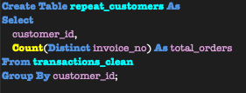

retention_rates for customer retention heatmap
cohort_sizes
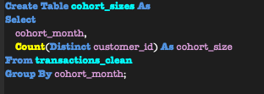
cohort_activity by month since cohort
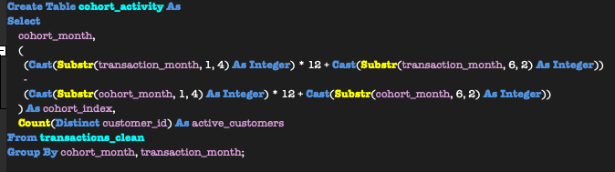

retention_rates
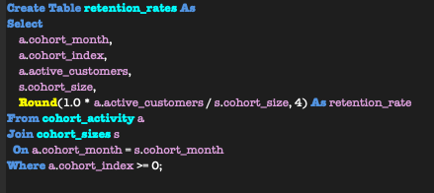
___________________________________________________________________________________
revenue_retention for revenue retention heatmap
revenue_by_cohort
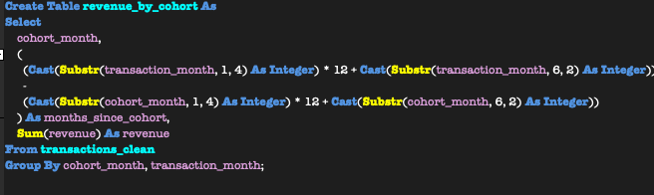

revenue_retention_base
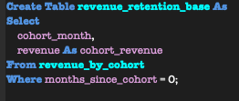

revenue_retention
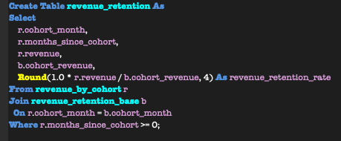

churn_over_time was built in Tableau

